What type of Art is This?

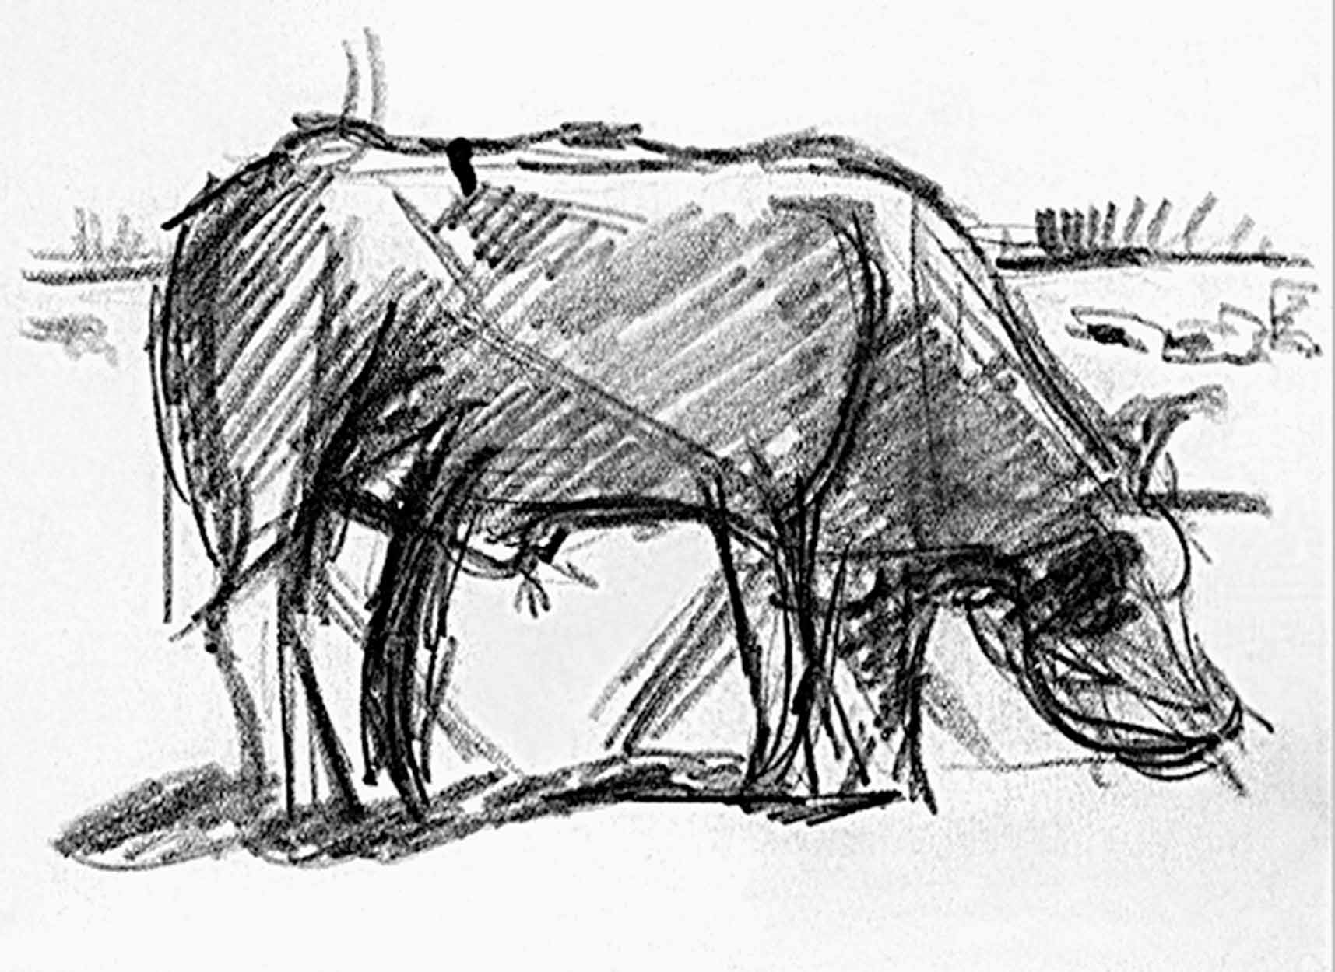

Theo van Doesburg (C.E.M. Kupper). Abstraction of a Cow. c. 1916. 4 5/8" x 6 1/4".

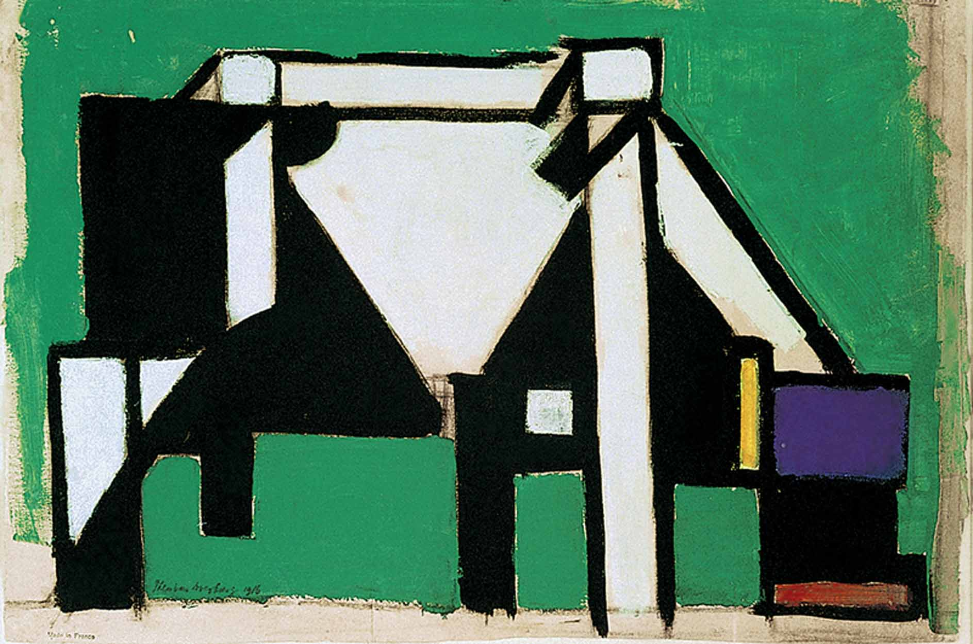

Theo van Doesburg (C.E.M. Kupper). Composition (The Cow). c. 1917. 15 5/8" x 22 3/4".

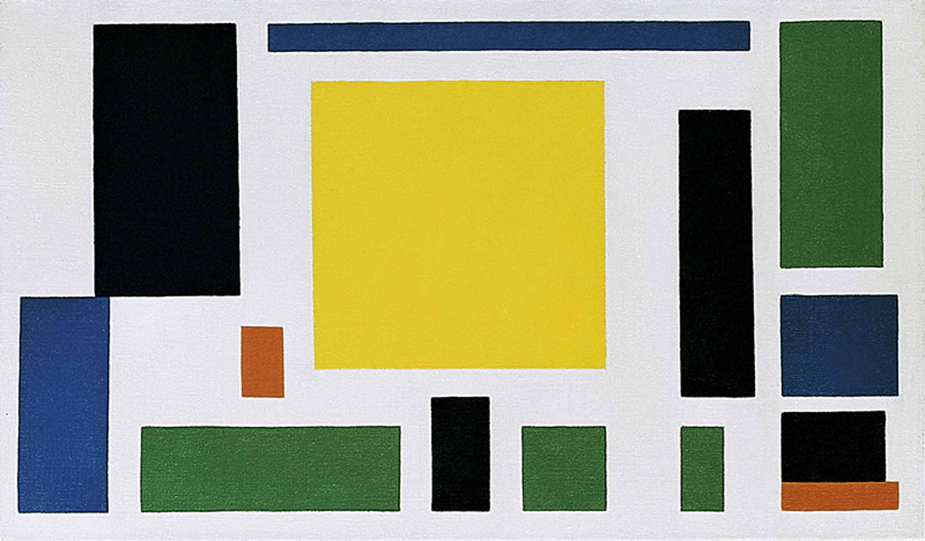

Theo van Doesburg (C.E.M. Kupper). Composition (The Cow). c. 1917. 14 3/4" x 25".

