Student Name: ______________________________________ Teacher Name: ______________________________
School Name: __________________________________ Grade Level: ________ Date: _____/_____/__________
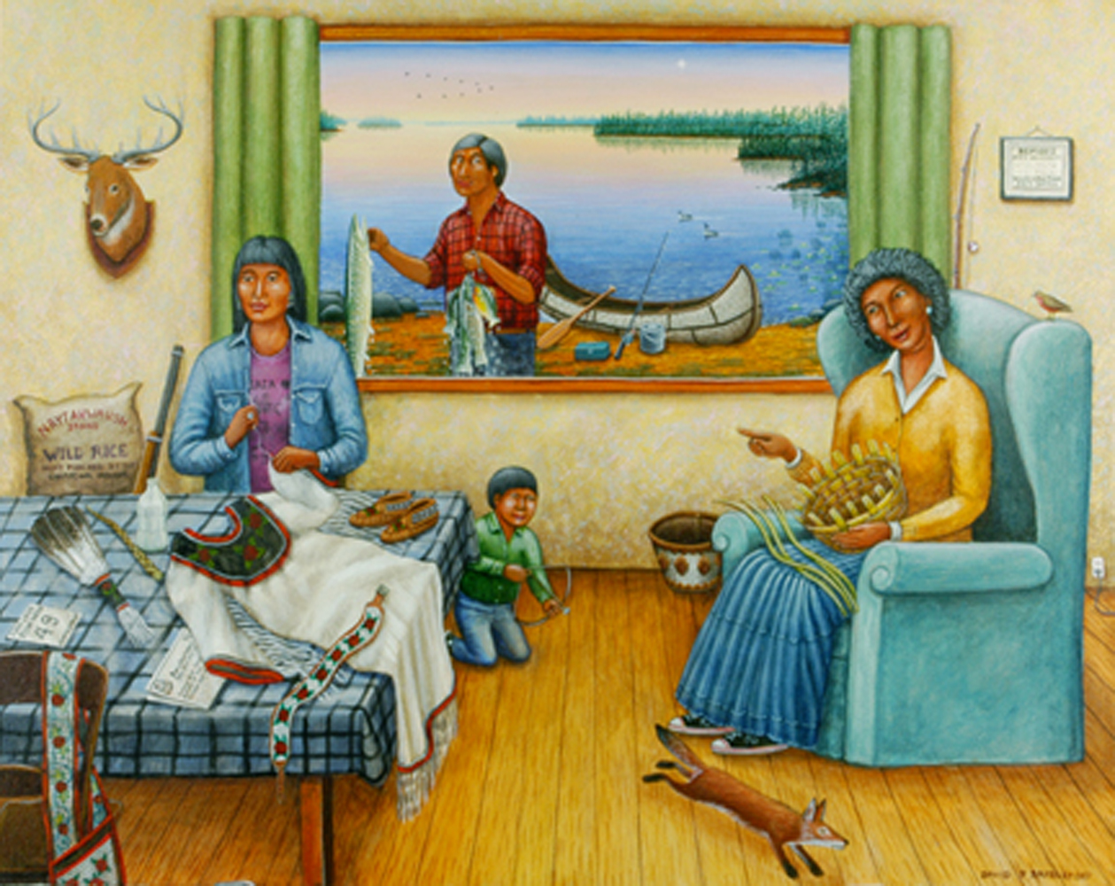

Look closely at this image. Think carefully about what you see. Ask yourself:
-What’s going on in this picture?
-What do I see that makes me say that?
-What more can I find?
You have 15 to 20 minutes to write. Try to organize your writing to make it easy for others to understand your thoughts. Be sure to read over your work and make corrections to your writing.

__________________________________________________________________________________

__________________________________________________________________________________

__________________________________________________________________________________

__________________________________________________________________________________

__________________________________________________________________________________

__________________________________________________________________________________

__________________________________________________________________________________

__________________________________________________________________________________

__________________________________________________________________________________

__________________________________________________________________________________

__________________________________________________________________________________

__________________________________________________________________________________

__________________________________________________________________________________

__________________________________________________________________________________

__________________________________________________________________________________

__________________________________________________________________________________

__________________________________________________________________________________

__________________________________________________________________________________

__________________________________________________________________________________

__________________________________________________________________________________

__________________________________________________________________________________

__________________________________________________________________________________

__________________________________________________________________________________

__________________________________________________________________________________

__________________________________________________________________________________

__________________________________________________________________________________

__________________________________________________________________________________

__________________________________________________________________________________

