Image #1 http://2.bp.blogspot.com/_iS16pyt0bik/Sct_Ki4KUvI/AAAAAAAAAR0/nEZBsQGoj1I/s1600/chinese+kung+fu+basics+kung+fu+martial+arts+techniques+kung+fu+shaolin+history+movie+kung+fu+fighting_2.jpg

Image #2 http://www.thecuttingedgenews.com/uploads/cmimg_12546.jpg

Image #3

Image #4 http://www.village.sussex.wi.us/images/thunde1.gif

Image #5 http://www.ssa.gov/history/pics/acoffee.jpg

Image #6 http://1.bp.blogspot.com/-QN4mnnz5vGc/TxdQS7WYh0I/AAAAAAAAAxg/DW1UJI9GLYY/s1600/Parade.jpg

Image #1 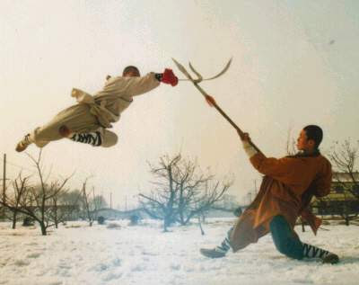

Image #2
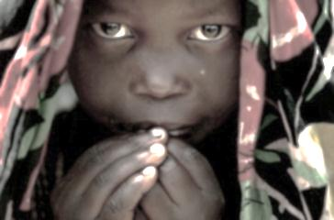

Image #3
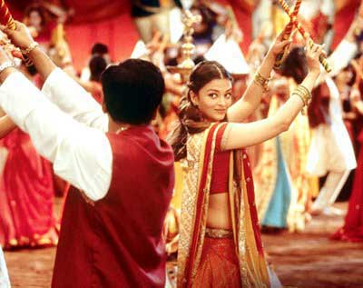

Image #4
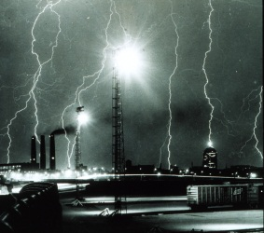

Image #5
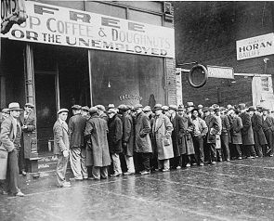

Image #6
